*********************************
“The strength of the team is each individual member. The strength of each member is the team.” ― Legendary Coach Phil Jackson

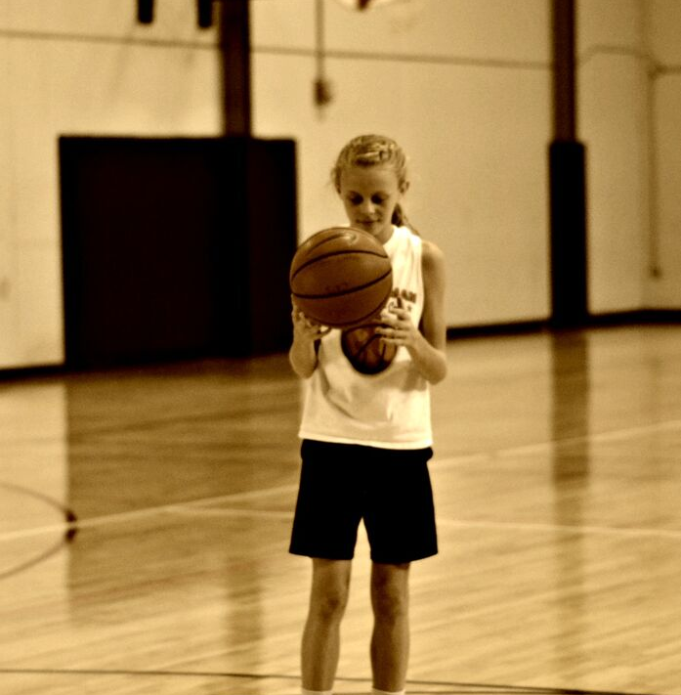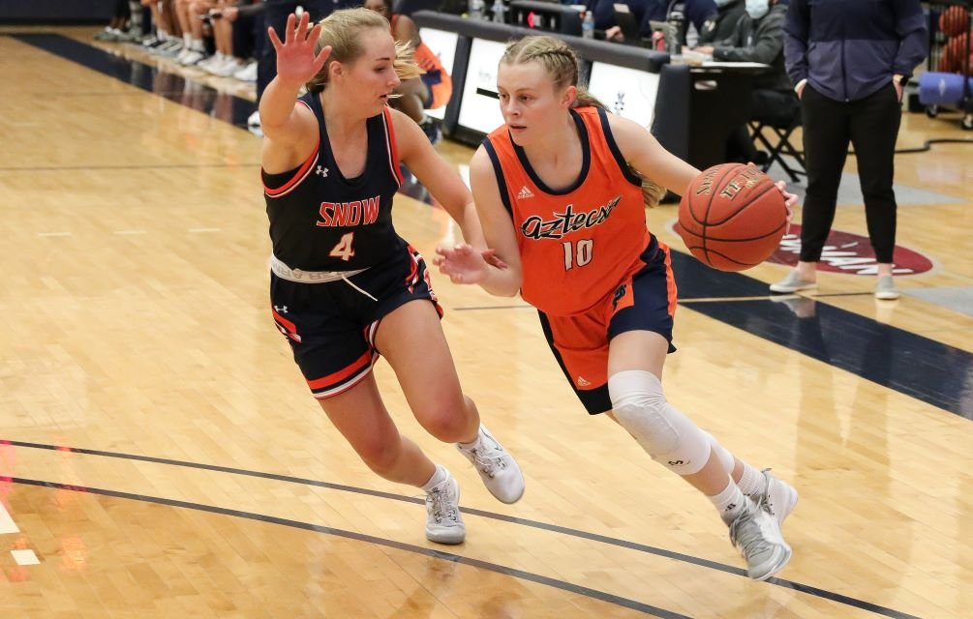
(Angel Addleman at 2015 camp and now at Pima College)

The Trojans Basketball Camp with Coach Al Addleman is an opportunity for girls entering 3rd-9th grade to improve their basketball skills in a fun and competitive atmosphere! Coach Addleman has been coaching High School, Middle School and club basketball for over 30 years, and has specialized in Rebuilding Programs and Individual Skill Development.

(Coach Addleman & 4 of his children, and daughter Alivea playing in McKale center

He is currently rebuilding the program at Catalina High School. Previous coaching experience includes Head Coaching at Sabino High School, Santa Rita High School, and Basis Tucson North High School, as well as Associate Head Coach at Pusch Ridge Christian Academy. Coach Addleman also coached the Tucson Cats club team for close to 20 years. Many of his former players have gone on to have very successful college basketball careers! His programs have all focused on an emphasis on solid, fundamental basketball, teaching kids the necessary skills to be successful both individually and as a member of a team.
The 11th Annual
Trojans Basketball Camp with Coach Al Addleman
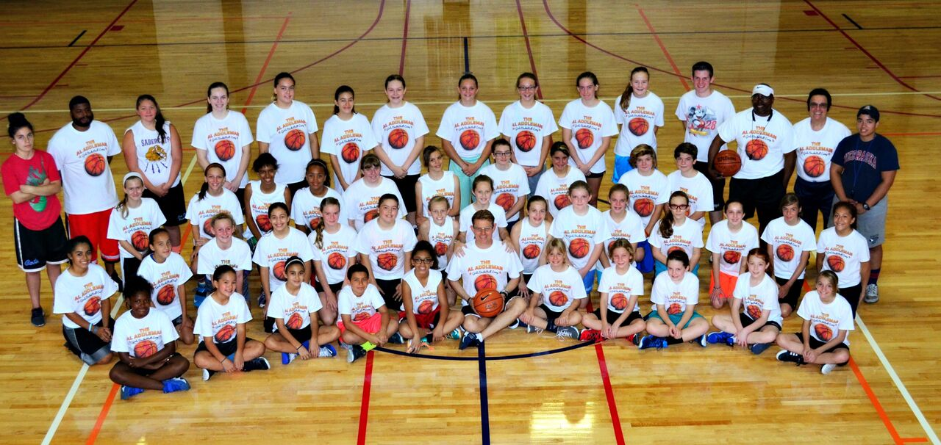
Previous Camp Photo

The Trojans Basketball Camp is THE BEST priced camp in Tucson
only $10!!

Where: Catalina High School
3645 E Pima St, Tucson, AZ 85716

When: Tuesday-Friday, May 31-June 3
What Time: 9:00am -12:00 noon

Each camper will also receive a free camp T-Shirt!
What do I need: Basketball shoes and clothes; water bottles with your name; a desire to learn and have fun!

How do I sign up?: The best way is to reserve your spot by sending a check and completed application by mail. However, you can also sign up and pay at the door. If you have questions,
Contact Coach Addleman by email at aaddleman@cox.net or call (520)907-6375.
Make checks payable to:
Al Addleman

Mail the completed form & check to:

Al Addleman
7424 E. Calle La Vega
Tucson AZ 85710

Daily Skill Builders!

Each day, the campers will break down into small groups to work on skills that include:

- Passing
- Shooting
- Dribbling
- Shooting form
- Defense
- Offense principles
- Rebounding

We will also have daily scrimmages, including1 on 1, 2 on 2, & 3 on 3, as well as other fun and challenging competitions.

Our staff: We have an experienced, talented, and dedicated coaching staff including current and former players that will be giving quality instruction and individual attention to all the campers!

Come be a part of this year’s exciting camp! Each summer of the Al Addleman camp, we have had up to 50 girl’s basketball players, many who have gone on to have very successful high school careers, as well as many who compete at the collegiate level. Who knows, you might be the next one!

Participant Information

Name________________________________

Address______________________________

Home Phone__________________________

Cell Phone____________________________

Email________________________________

Age_____________Grade entering ________

School attending next year________________

T-Shirt size_____________

Primary Contact (Parent or Guardian)

_____________________________________

Phone________________________________

Alternate Phone________________________

Email________________________________

Secondary Contact (Parent or Guardian)

_____________________________________

Phone________________________________

Email________________________________

Medical Information

Any Medical Conditions we should be aware of:

______________________________________
Any medications currently taking:
______________________________________
Any Allergies:
_______________________________________
(If none, please write “None”)
_______________________________________

Primary Insurance company:
______________________________________

Group/Policy #:____________________________

Family Physician name:_____________________

Physician Phone:___________________________

In the event of a medical emergency during camp activities, I authorize you to obtain proper medical care. I will assume financial responsibility for any bills incurred through my insurance company.

Signed________________________________
Date:_________________________________

Release of Liability

(Camp Participant), _______________________ has my permission to participate in all camp activities that occur at the Al Addleman basketball camp. I recognize that the coaches and leaders are serving to the best of their ability and release them from any or all liability regarding any injury that may occur through the activities related to this camp.

Signed:_________________________________

Date:___________________________________

The

Trojans Basketball Camp with

Coach Al Addleman

Girls Camp
Girls entering grades 3-9
Tuesday May 31-Friday June 3
9:00a-12:00p

Catalina High School
3645 E Pima St,
Tucson, AZ 85716

Tuesday May 31-Friday June 3
Weekdays 9:00a-12p
Cost: $10
(520) 907-6375
aaddleman@cox.net

